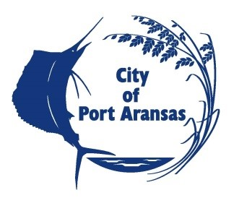

The City Of Port Aransas is taking a survey on the possible addition of hangar space to be located at the Mustang Beach Airport, Port Aransas, Texas. Please take a few moments to fill out the below information so we can process what potential hangar owners would like in a new hanger space. This survey is a follow-up to a previous survey and is being sent to all persons currently on the Mustang Beach Airport Hangar waiting list. If you have any questions please feel free to contact Stephanie Montgomery at 361-749-4111 or smontgomery@cityofportaransas.org .
**If you are currently on the Mustang Beach Airport Waiting list you will remain in the same position you are currently in. Filling out this survey will not effect your current status on the waiting list***

- Name:
City, State, Zip
Cell Phone Number:
Work Phone Number:
Home Phone Number:
Email address:

- Aircraft information:
Make:
Model:
Tail Number:
Wingspan:
Minimum Acceptable Door Height:
- What month/year would you start hangar rental or hangar construction?

- Would you prefer a City owned large “community” hangar area for transient usage or would you prefer to lease land from the City and build a private hangar space?

- If you would prefer a private hangar space, what building foot print would you like to build, size, dementions, etc. ?

- Would you prefer a bifold or a single piece hinged at the top door that would be operated hydraulically?

(NOTE: If the hangar is to be used for an airport related business and no specific tail number is associated with the hangar, indicate the type of business that will be occupying the hangar and the size and type of hangar required.)

Please list any other Airport Services you would like to see at Mustang Beach Airport.

