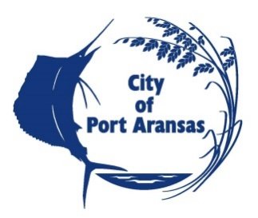

CITY OF PORT ARANSAS, TEXAS
REQUEST FOR BID
PHASE 1 CHARLIE’S PASTURE SHORELINE TEMPORARY BULKHEAD REPAIR

NOTICE TO BIDDERS

NOTICE is hereby given that the City of Port Aransas, Texas, is requesting bids for Temporary Bulkhead Repair at Charlie’s Pasture Bulkhead. All bids must be clearly marked “SEALED BID – Phase 1 Charlie’s Pasture Shoreline Temporary Bulkhead Repair” to the City of Port Aransas City Secretary’s office, 710 W. Avenue A, Port Aransas, Texas prior to Thursday, September 17, 2020 at 2:00 pm, at which time they will be publicly opened and acknowledged in the City Hall Council Chamber. Any bid delivered or received after 2:00 pm will not be considered and shall be returned unopened to the addressee. The City reserves the right to reject any or all bid.

The Construction Documents are available on-line at www.cityofportaransas.org or at Urban Engineering, 2725 Swantner Dr, Corpus Christi, TX 78404.

Any and all questions or requests for information relating to this request for bid may be directed to William Causey of Urban Engineering, the Project Engineer for the City of Port Aransas, via email at williamc@urbaneng.com, no later than 4:00 P.M. CST on Wednesday, September 9, 2020.

POSTED this 20th day of AUGUST, 2020 on the bulletin board at Port Aransas City Hall, 710 W Avenue A, Port Aransas, Texas and on the webpage www.cityofportaransas.org. TIME: 5:00 p.m. PUBLISHED in The South Jetty in the Thursday, August 20 and August 27, 2020 editions.

