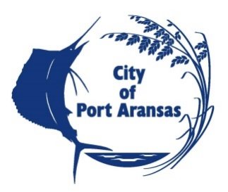

CITY OF PORT ARANSAS, TEXAS
REQUEST FOR BID
HIGH PRESSURE GAS MAIN REPLACEMENT

NOTICE TO BIDDERS

NOTICE is hereby given that the City of Port Aransas, Texas, is requesting bids for High Pressure Gas Main Replacement Project. All bids must be clearly marked “SEALED BID – High Pressure Gas Main Replacement” to the City of Port Aransas City Secretary’s office, 710 W. Avenue A, Port Aransas, Texas prior to Thursday, October 22, 2020 at 2:00 pm, at which time they will be publicly opened and acknowledged in the City Hall Council Chamber. Any bid delivered or received after 2:00 pm will not be considered and shall be returned unopened to the addressee. The City reserves the right to reject any or all bid.

The Construction Documents are available on-line at www.cityofportaransas.org or at Urban Engineering, 2725 Swantner Dr, Corpus Christi, TX 78404.

A pre-bid video conference will be held on Thursday, October 8, 2020 at 10:00 am. For information and video please contact City Hall at 361-749-4111 or city@cityofportaransas.org.

Any and all questions or requests for information relating to this request for bid may be directed to William Causey of Urban Engineering, the Project Engineer for the City of Port Aransas, via email at williamc@urbaneng.com, no later than 4:00 P.M. CST on Wednesday, October 14, 2020.

POSTED this 10th day of SEPTEMBER, 2020 on the bulletin board at Port Aransas City Hall, 710 W Avenue A, Port Aransas, Texas and on the webpage www.cityofportaransas.org. TIME: 5:00 p.m. PUBLISHED in The South Jetty in the Thursday, September 10, 2020 and September 17, 2020 editions.

