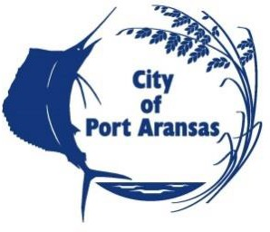

CITY OF PORT ARANSAS, TEXAS

A REQUEST FOR QUALIFICATIONS (RFQ)
FROM PROFESSIONAL CONSULTANTS
TO REVIEW AND UPDATE THE COMPREHENSIVE PLAN AND IMPACT FEES

NOTICE TO BIDDERS
NOTICE is hereby given that the City of Port Aransas, Texas is soliciting proposals from qualified companies and individuals to assist the City with review and update of the Port Aransas comprehensive plan and to update City’s impact fees; Roadway use, parks and drainage (new).

Sealed proposals must be clearly marked “Comprehensive Plan and Impact Fee Consulting Services” to the City Secretary, Francisca Nixon, City of Port Aransas, 710 W. Avenue A, Port Aransas, Texas 78373 prior to Friday, October 15th, 2021 at 3:00 pm, at which time they will be publicly opened and acknowledged in the City Hall Council Chamber. Any RFQ delivered or received after 3:00 pm will not be considered and shall be returned unopened to the addressee. The City reserves the right to reject any or all proposals.

Request for Proposal (RFP) is available on-line at www.cityofportaransas.org or at City Hall, 710
W. Avenue A, Port Aransas, Texas 78373. Any and all questions or requests for information relating to this Request for Proposal shall be submitted to Rick Adams via e-mail at radams@cityofportaransas.org Questions regarding RFQ will be accepted until 5:00 pm, October 12th, 2021

POSTED this 28th day of September 2021 on the bulletin board at Port Aransas City Hall,
710 W Avenue A, Port Aransas, Texas 78373 and on the City’s webpage www.cityofportaransas.org. TIME: 12:00 p.m. PUBLISHED in The South Jetty in the Wednesday, September 30th and October 7th, 2021 editions.

CITY OF PORT ARANSAS, TEXAS

__________________________
Francisca Nixon, City Secretary

